#Q1 Provide the list of markets in which customer "Atliq Exclusive" operates its business in the APAC region.  
**SELECT DISTINCT** market  
**FROM** dim_customer  
**WHERE** customer="Atliq Exclusive" **AND** region=**"**APAC**"**;

#Q2 What is the percentage of unique product increase in 2021 vs. 2020? The final output contains these fields: unique_products_2020, unique_products_2021 & percentage_chg.  
  
**WITH** cte **AS**(  
**SELECT** COUNT(**DISTINCT**(product_code)) **AS** unique_products_2020

**FROM** fact_sales_monthly

**WHERE** fiscal_year=2020),

cte1 **AS** (**SELECT** COUNT(**DISTINCT**(product_code)) **AS** unique_products_2021

**FROM** fact_sales_monthly

**WHERE** fiscal_year=2021)

**SELECT** *, ROUND((unique_products_2021-unique_products_2020)/unique_products_2020 *100, 2) **AS** percentage_chg

**FROM** cte, cte1;

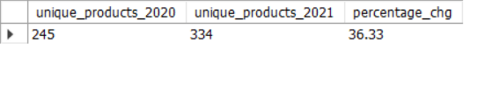

#Q3

**SELECT** segment, COUNT(product_code) **AS** product_count

**FROM** dim_product

**GROUP** **BY** segment

**ORDER** **BY** product_count **DESC**;

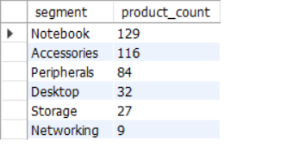

#Q4

**WITH** cte1 **AS**(

**SELECT** d.segment, COUNT(**DISTINCT** f.product_code) **AS** product_count_2020

**FROM** dim_product d

**JOIN** fact_sales_monthly f

**ON** d.product_code=f.product_code

**WHERE** fiscal_year=2020

**GROUP BY** d.segment),

cte2 **AS**(

**SELECT** d.segment AS segment_, COUNT(DISTINCT f.product_code) **AS** product_count_2021

**FROM** dim_product d

**JOIN** fact_sales_monthly f

**ON** d.product_code=f.product_code

**WHERE** fiscal_year=2021

**GROUP** **BY** d.segment),

cte3 **AS**(SELECT *, (product_count_2021-product_count_2020) **AS** difference

**FROM** cte1 c1

**JOIN** cte2 c2

**ON** c1.segment=c2.segment_

**ORDER** **BY** difference **DESC**)

**SELECT** segment, product_count_2020, product_count_2021, difference

**FROM** cte3;

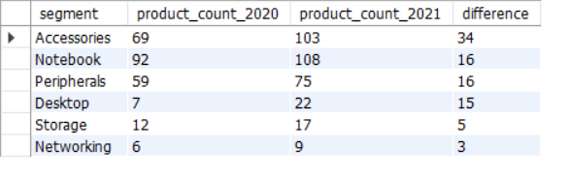

#Q5

**SELECT** d.product_code, d.product, f.manufacturing_cost

**FROM** dim_product d

**JOIN** fact_manufacturing_cost f

**ON** d.product_code=f.product_code

**WHERE** manufacturing_cost= (**SELECT** MAX(manufacturing_cost) **AS** max_ **FROM** fact_manufacturing_cost) **OR** manufacturing_cost= (**SELECT** MIN(manufacturing_cost) **AS** min_ **FROM** fact_manufacturing_cost)

**ORDER** **BY** manufacturing_cost **DESC**;

#Q6

**SELECT** d.customer_code, d.customer, ROUND(**AVG**(pre_invoice_discount_pct),4) **AS** average_discount_percentage

**FROM** dim_customer d

**JOIN** fact_pre_invoice_deductions f

**ON** d.customer_code=f.customer_code

**WHERE** f.fiscal_year=2021 **AND** d.market="India"

**GROUP** **BY** d.customer_code

**ORDER** **BY** average_discount_percentage **DESC**

**LIMIT** 5;

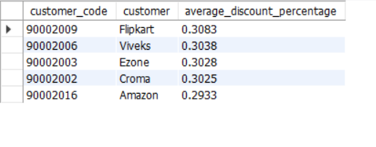

#Q7

**SELECT** MONTHNAME(**date**) **AS** month_, s.fiscal_year, ROUND(SUM((gross_price*sold_quantity)),2) **AS** gross_sales_amount

**FROM** fact_gross_price f

**JOIN** fact_sales_monthly s

**ON** f.product_code=s.product_code

**JOIN** dim_customer d

**ON** d.customer_code=s.customer_code

**WHERE** customer="Atliq Exclusive"

**GROUP** **BY** s.fiscal_year, month_

**ORDER** **BY** s.date;

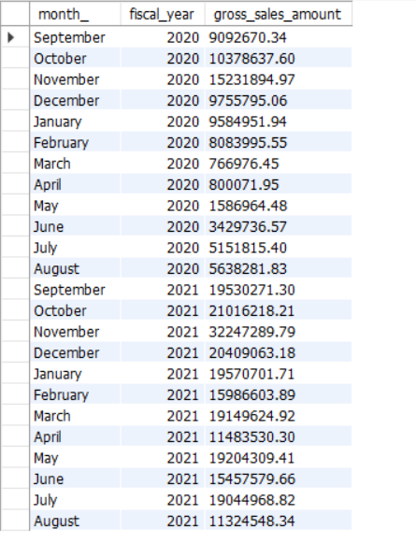

#Q8

**WITH** cte **AS**(

**SELECT** **MONTH**(**date**) **AS** m_, SUM(sold_quantity) **AS** tot

**FROM** fact_sales_monthly

**WHERE** fiscal_year=2020

**GROUP** **BY** m_)

**SELECT** **CASE** **WHEN** m_ **IN**(9,10,11) **THEN** "1"  
 **WHEN** m_ **IN**(12,1,2) **THEN** "2"

**WHEN** m_ **IN**(3,4,5) **THEN** "3" **ELSE** "4" **END** **AS** Quarters, SUM(tot) **AS** total_sold_quantity

**FROM** cte

**GROUP** **BY** Quarters

**ORDER** **BY** total_sold_quantity **DESC**;

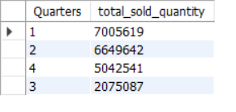

#9

**WITH** cte **AS**(

**SELECT** d.channel, ROUND(SUM((f.sold_quantity*g.gross_price))/1000000, 2) **AS** gross_sales_mln

**FROM** dim_customer d

**JOIN** fact_sales_monthly f

**ON** d.customer_code=f.customer_code

**JOIN** fact_gross_price g

**ON** f.product_code=g.product_code

**WHERE** f.fiscal_year=2021

**GROUP** **BY** d.channel

**ORDER** **BY** gross_sales_mln DESC)

**SELECT** *, ROUND(gross_sales_mln/(**SELECT** SUM(gross_sales_mln) **FROM** cte)*100, 2) **AS** percentage

**FROM** cte;

#Q10

**WITH** cte **AS**(

**SELECT** d.division, f.product_code, d.product, SUM(f.sold_quantity) **AS** total_sold_quantity, **RANK**() **OVER** (**PARTITION** **BY** d.division **ORDER** **BY** SUM(f.sold_quantity) **DESC**) **AS** rank_order

**FROM** dim_product d

**JOIN** fact_sales_monthly f

**ON** d.product_code = f.product_code

**WHERE** f.fiscal_year = 2021

**GROUP** **BY** d.division, f.product_code, d.product)

**SELECT** division, product_code, product, total_sold_quantity, rank_order

**FROM** cte

**WHERE** rank_order **IN** (1, 2, 3);

